
KHANGCHENDZONGA CONSERVATION COMMITTEE
Yuksam, Gyalshing District, West Sikkim, 737113.
KCC
_____________________________________________________________________________
Ref: 2023345/KCC/2025 Dated: 01.11.2025
TENDER NOTICE

Tender Notice

Sealed Quotations are invited from interested and eligible agencies for the construction of building roof of Khangchendzonga Conservation Committee (KCC) building, Yuksam, Gyalshing District, West Sikkim under DST funder project being implemented at KCC.
Details of the tender work:
Estimated Cost | Rs. 15 lakhs
Eligibility class of enlistment/registration | IV
Time limit | 1.5 month

Terms and Conditions
- Sealed quotation should be submitted along with Covering Letter (signed and sealed in official letter head).
- Interested bidders may submit their quotations in a sealed envelope, superscribed as "Quotation for construction of KCC building roof" on top of the envelope & documents through post/by hand on or before 10.11.2025 to the following address:
The Principal Investigator
DST Project
Khangchendzonga Conservation Committee (KCC)
Yuksam, Gyalshing District, West Sikkim-737113
- Individual or society or agencies with 4th grade enlistment certificate with PAN card, GST registration, and other statutory compliances can participate.
For further inquiry call at 97331-49975/95938-83444

Description of works: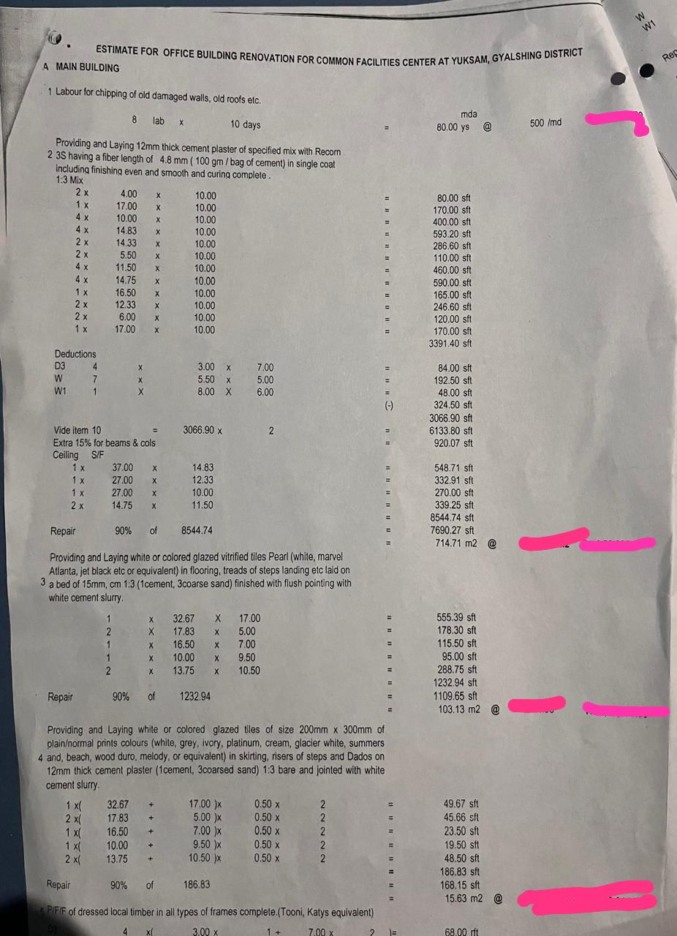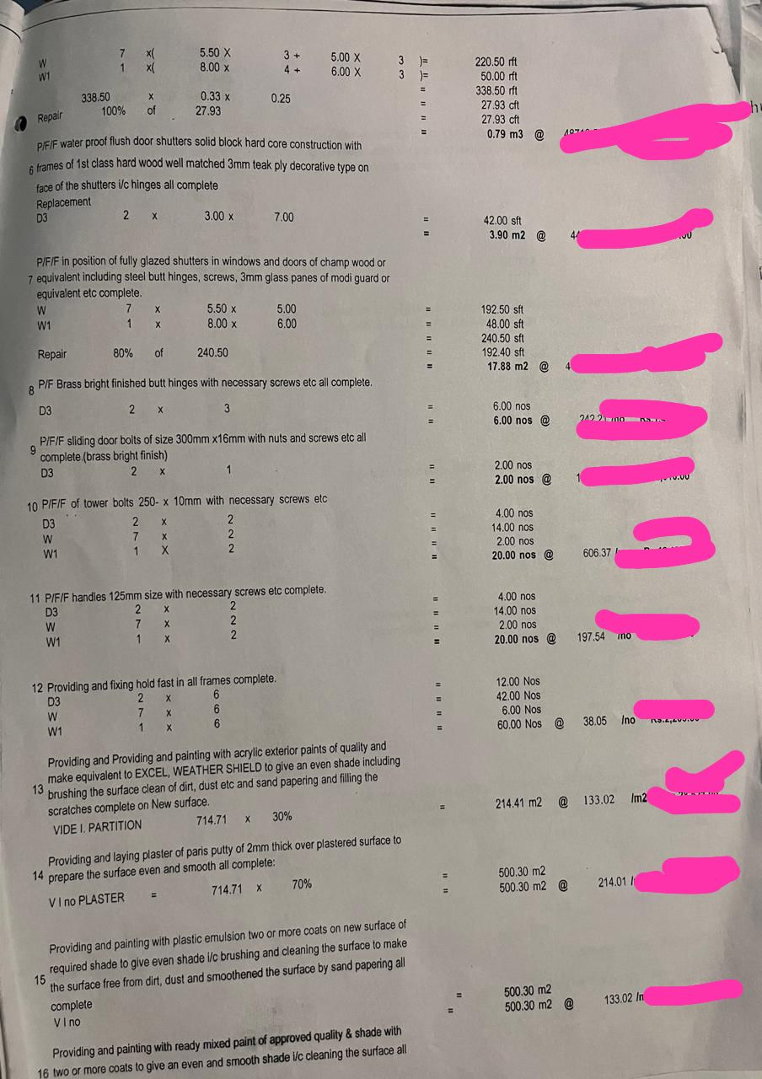 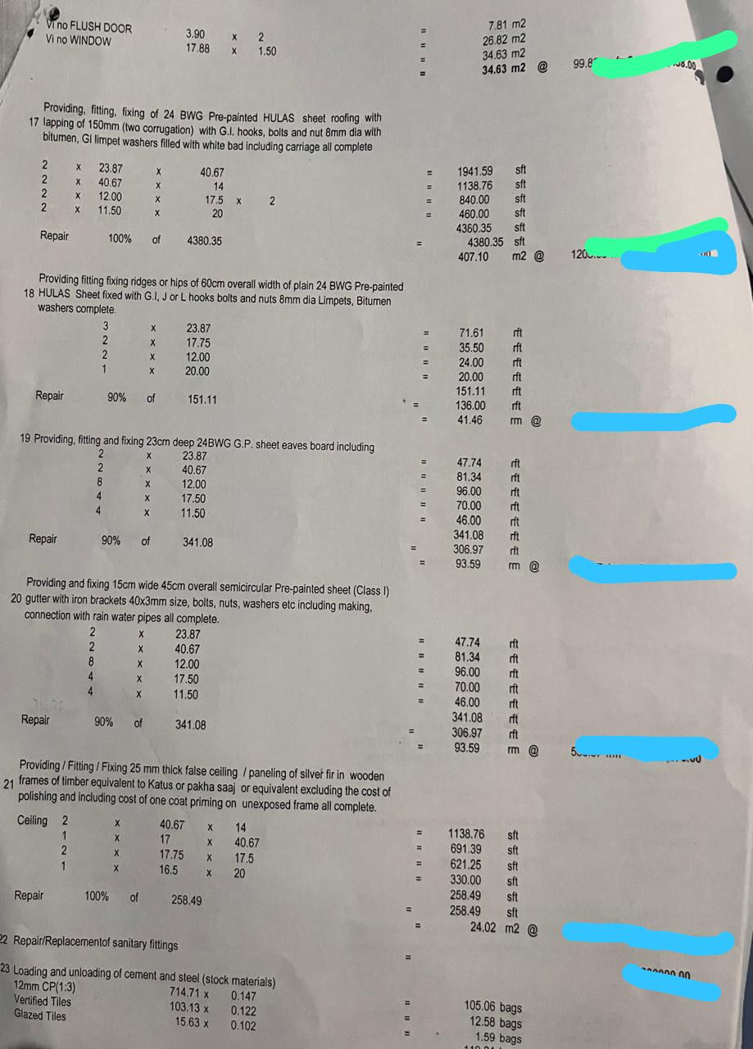 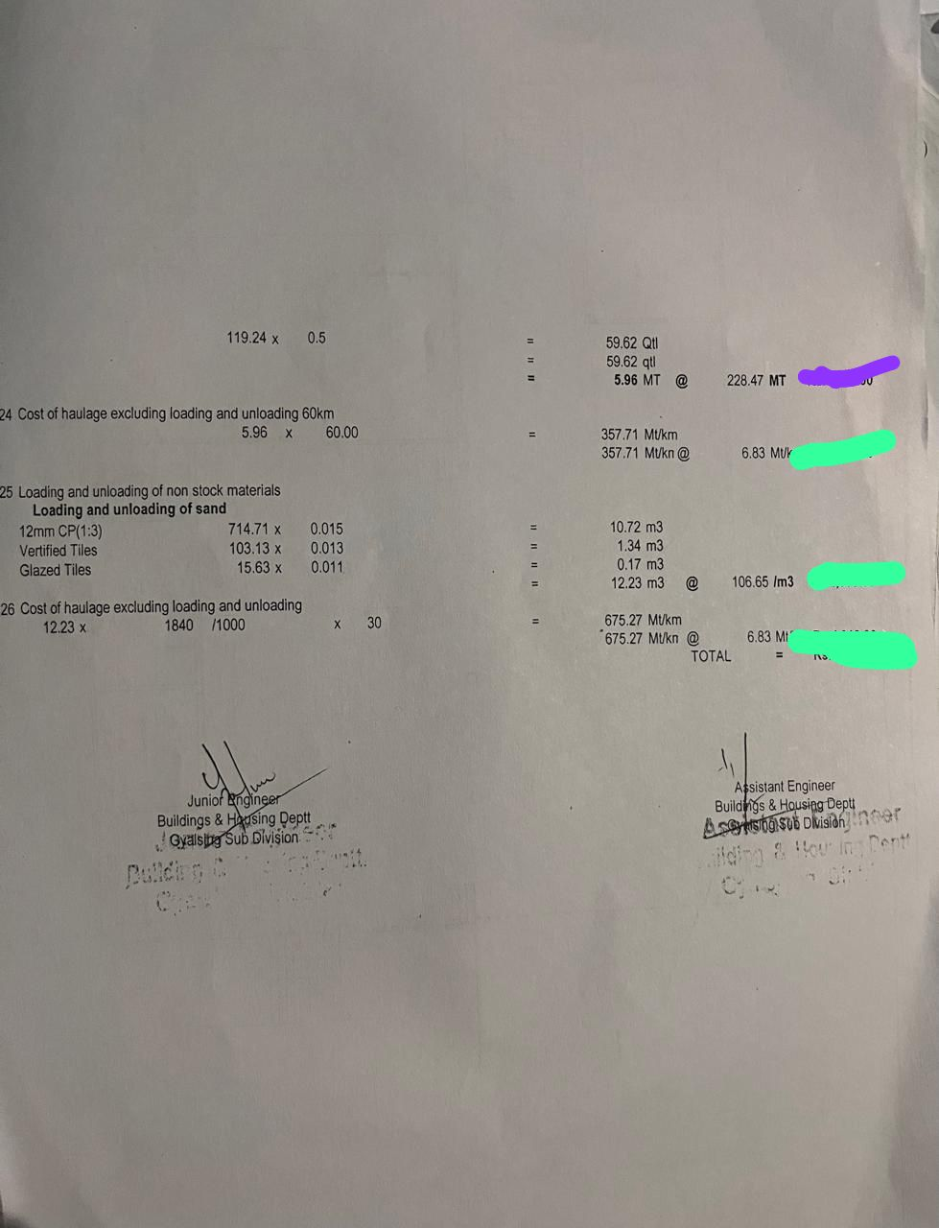

-sd
Principal Investigator, DST Project
Khangchendzonga Conservation Committee, Sikkim.

